Chapter 18, Solution 50.

Consider the circuit shown below:
1 Ω
1 Ω
jω
+
v_{o}
−
V_{S}

+
−
i₁
i₂
j0.5ω
jω

For loop 1,
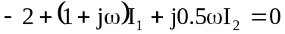 (1)
For loop 2,
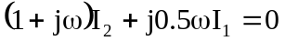 (2)
From (2),
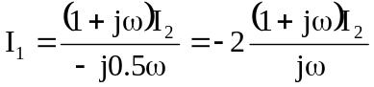

Substituting this into (1),
